Tree
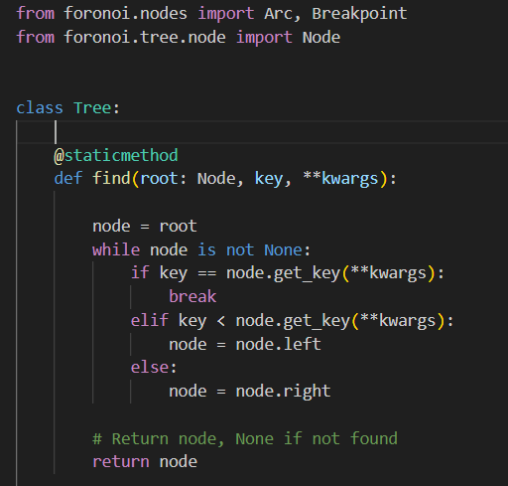

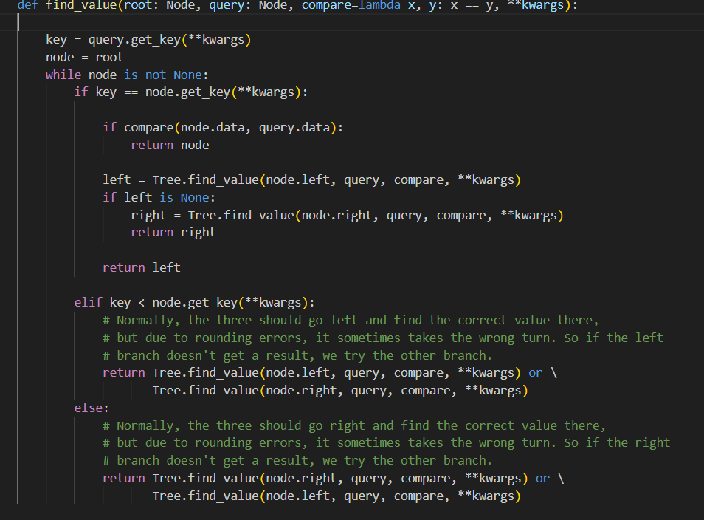
"""
Find an item using a query node and a comparison function.

:param root: (Node) The root to start searching from
:param query: The query
:param compare: (lambda) Lambda expression to compare the node against the query. Will be called as
compare(node.data, query.data).
:param kwargs: Optional arguments to be passed to the get_key() functions
:return: (Node or None) Returns the node that corresponds to the query or None
"""
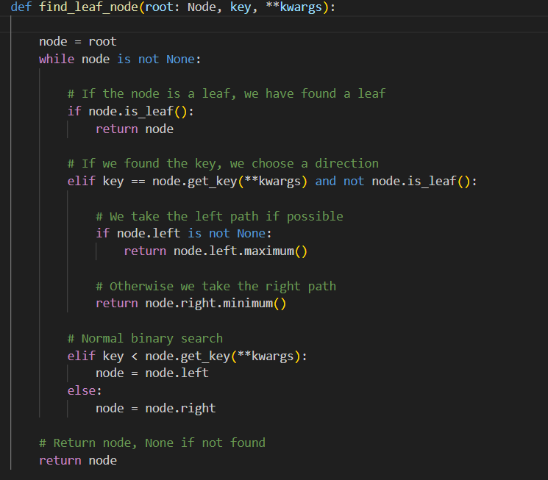
"""
Follows a path downward between the internal nodes using the key until it
reaches a leaf node. If it is unclear which path to take, the left path is
taken.

:param root: (Node) The root of the (sub)tree to travel down
:param key: The key to use to determine the path
:param kwargs: Optional arguments passed to the get_key() functions
:return: (Node) The node found at the end of the journey
"""
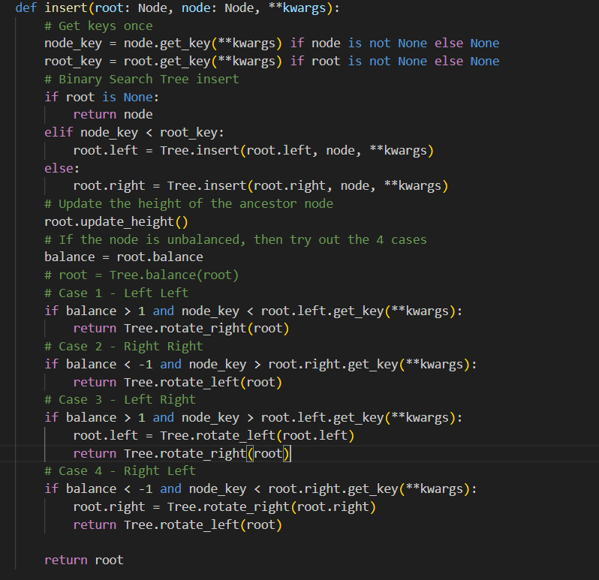

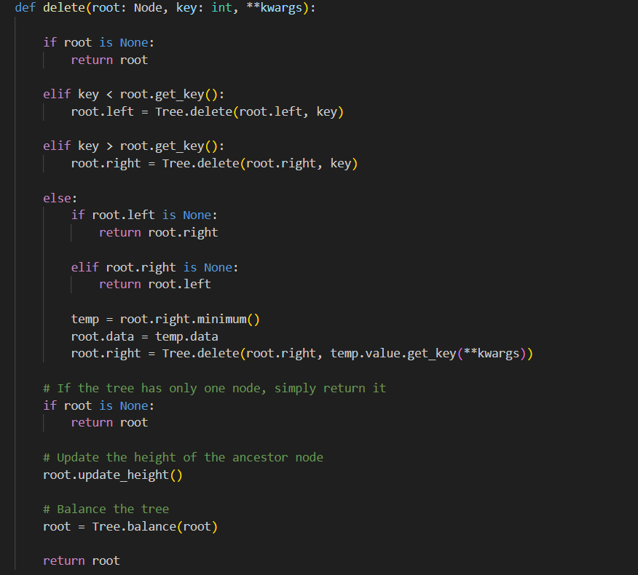
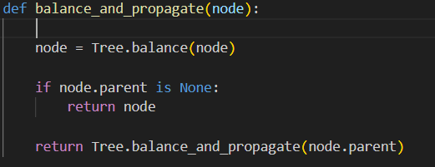

"""
Walks up the tree recursively to rebalance all nodes, until it reaches the new root.

:param node: The starting point, everything below this point is assumed to be balanced.
:return: The root of the balanced tree
"""
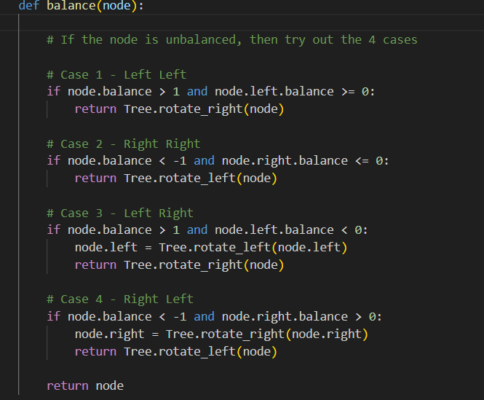
"""
Make the three balanced if it is unbalanced.
:param node: (Node) The root node of the tree to balance
:return: (Node) The new root of the sub tree
"""
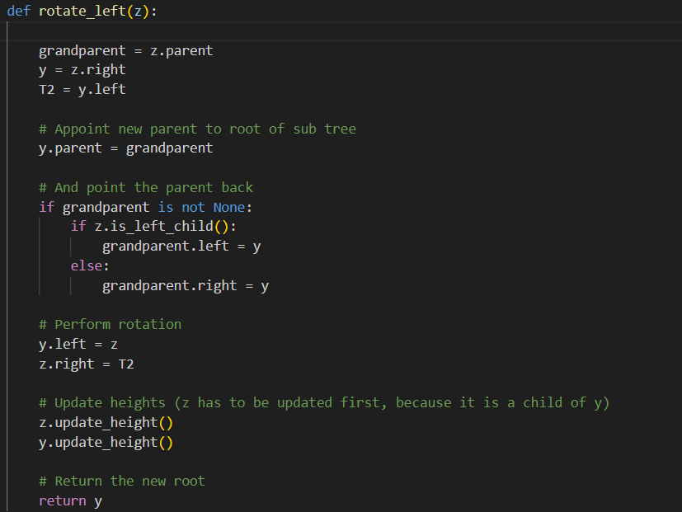
"""
Rotate tree to the left.

:param z: (Node) The root of the sub tree
:return: (Node) The new root of the sub tree
"""
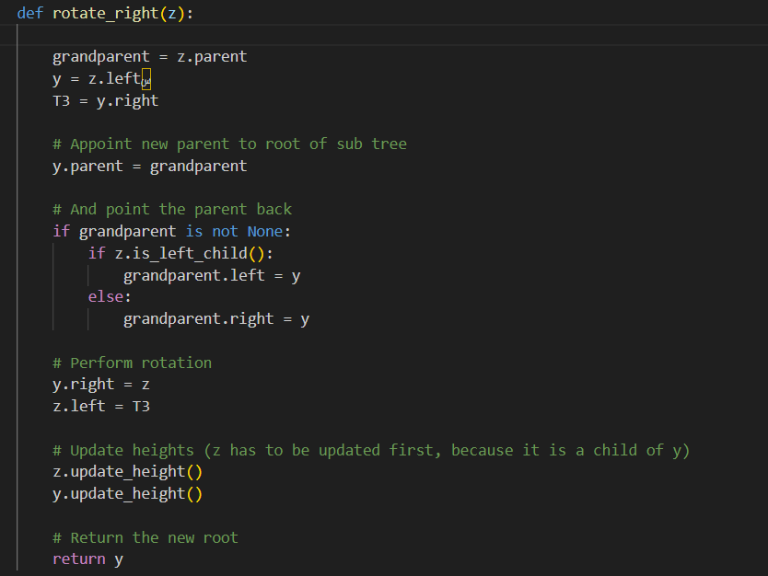
"""
Rotate tree to the right.

:param z: (Node) The root of the sub tree
:return: (Node) The new root of the sub tree
"""
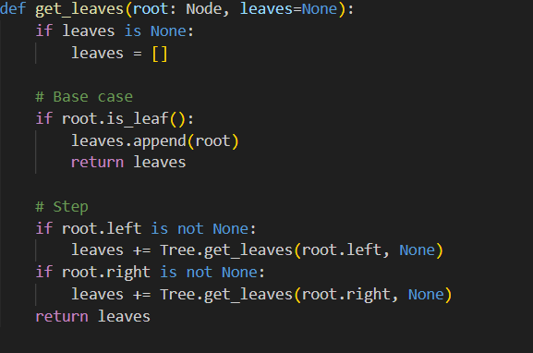
Node:
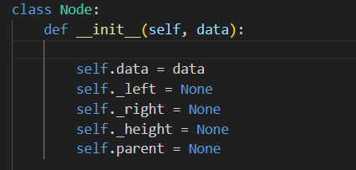
"""
A smart tree node with some extra functionality over standard nodes.
:param data: Data that is stored inside the node.
"""

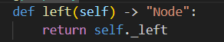

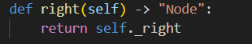

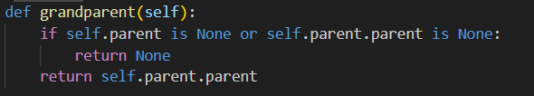

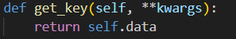

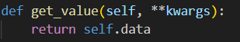

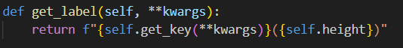

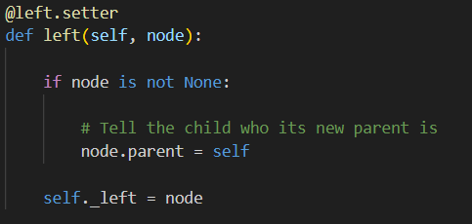
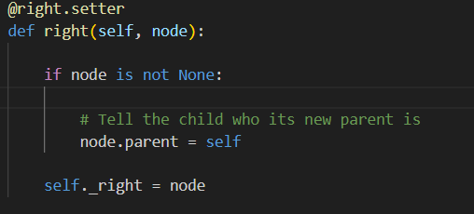
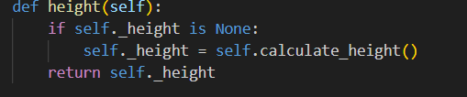
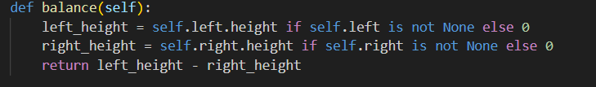
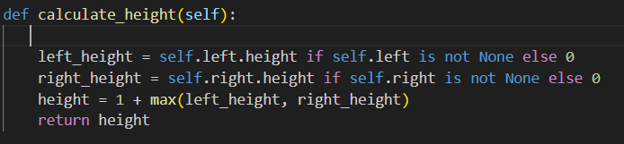
"""
Recursively calculate height of this node.
Height calculated for each node will be stored, so calculations need to be done only once.
:return: (int) Height of the current node
"""
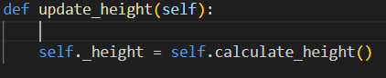
"""
Recalculate the height of the node.
"""
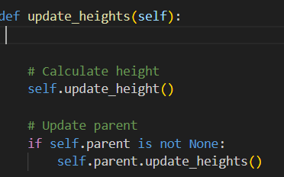
"""
Recalculate the heights of this node and all ancestor nodes.
"""
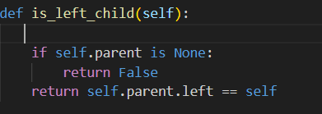
"""
Determines whether this node is a left child.
:return: (bool) True if this node is a left child, False otherwise
"""
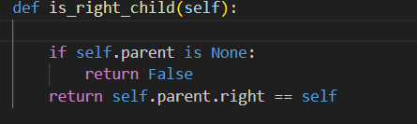
"""
Determines whether this node is a right child.
:return: (bool) True if this node is a right child, False otherwise
"""
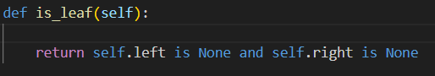
"""
Determines whether this node is a leaf.
:return: (bool) True if this node is a leaf, False otherwise
"""
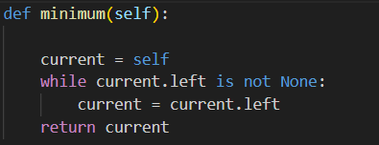
"""
Determines the node with the smallest key in the subtree rooted by this node.
:return: (Node) Node with the smallest key
"""
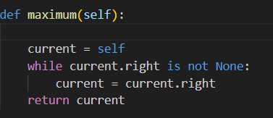
"""
Determines the node with the largest key in the subtree rooted by this node.
:return: (Node) Node with the largest key
"""
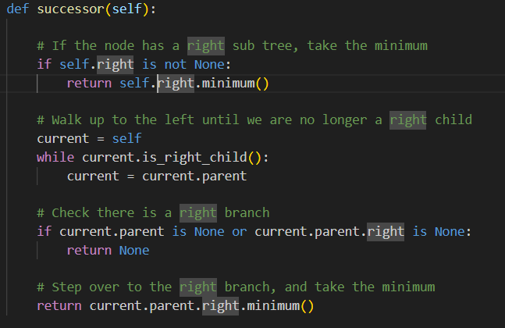
"""
Returns the node with the smallest key larger than this node's key, or None
if this node has the largest key in the tree.
"""
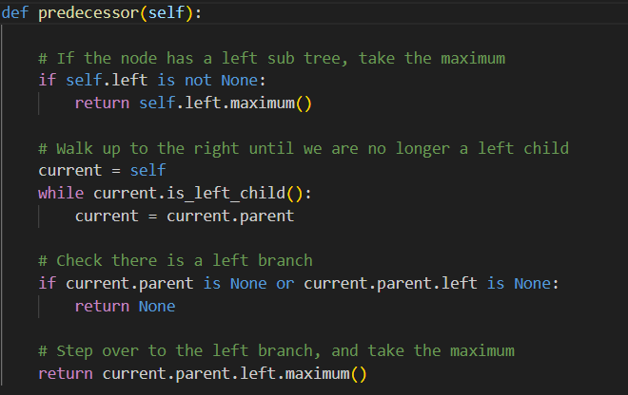
"""
Returns the node with the largest key smaller than this node's key, or None
if this node has the smallest key in the tree.
"""
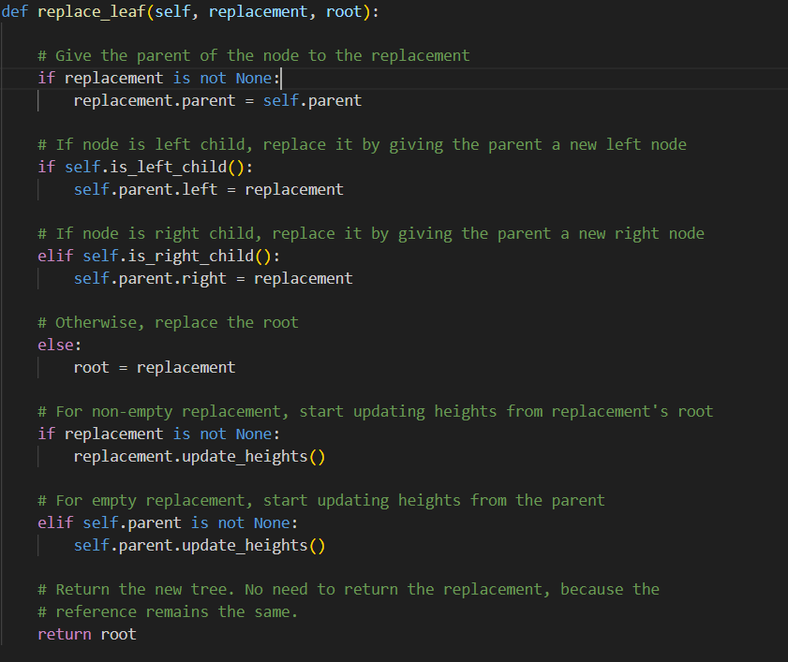
"""
Replace the node by a replacement tree.
Requires the current node to be a leaf.

:param replacement: (Node) The root node of the replacement sub tree
:param root: (Node) The root of the tree
:return: (Node) The root of the updated tree
"""
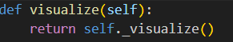
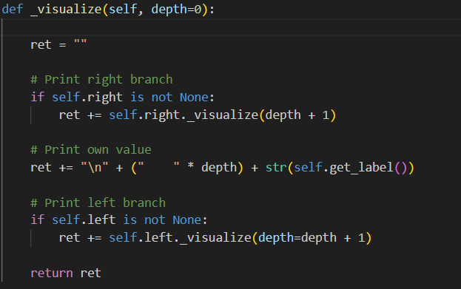
"""
Visualize the node and its descendants.

:param depth: (int) Used by the recursive formula, should be left at the default value
:return: (str) String representation of the visualization
"""

